**MCOMD1MCS – Mathematics for Computing**

**Assignment 2**

**Lecturer – James Cugley**

**Student – Nathan Shuttleworth**

**Year – 2019/2020**

**Hand in – 9/1/2020**

Task 1:

Working:

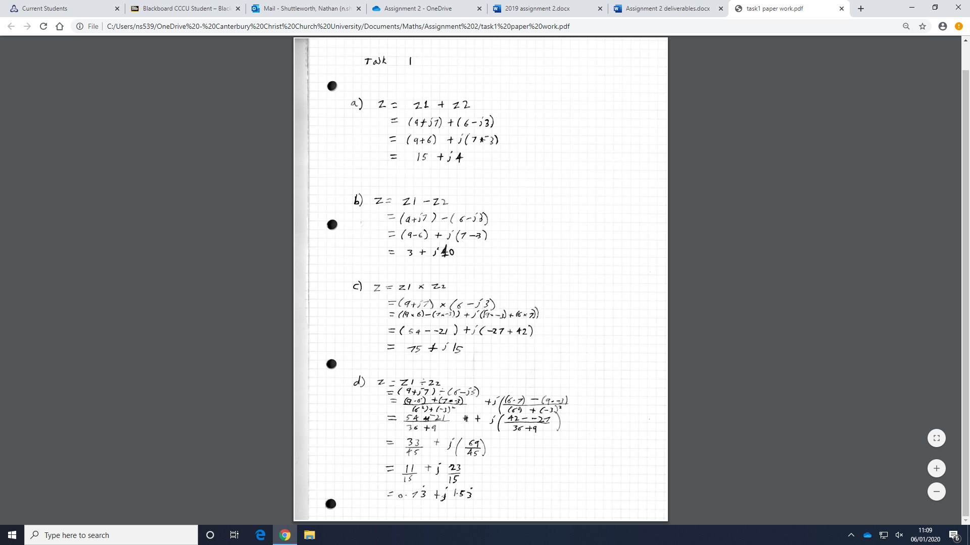

Code:

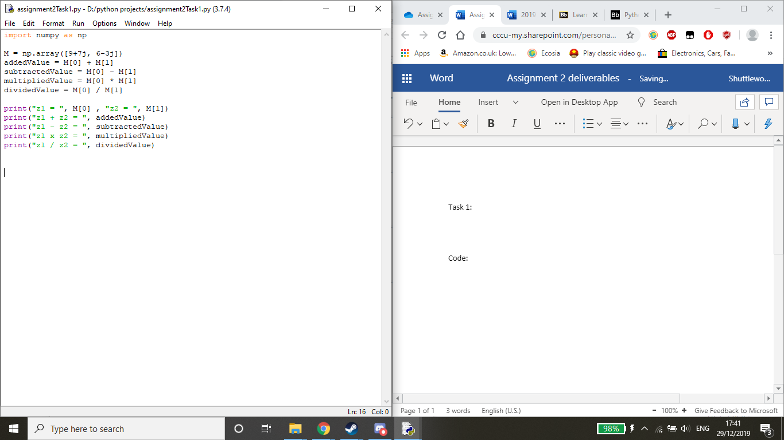

Output:

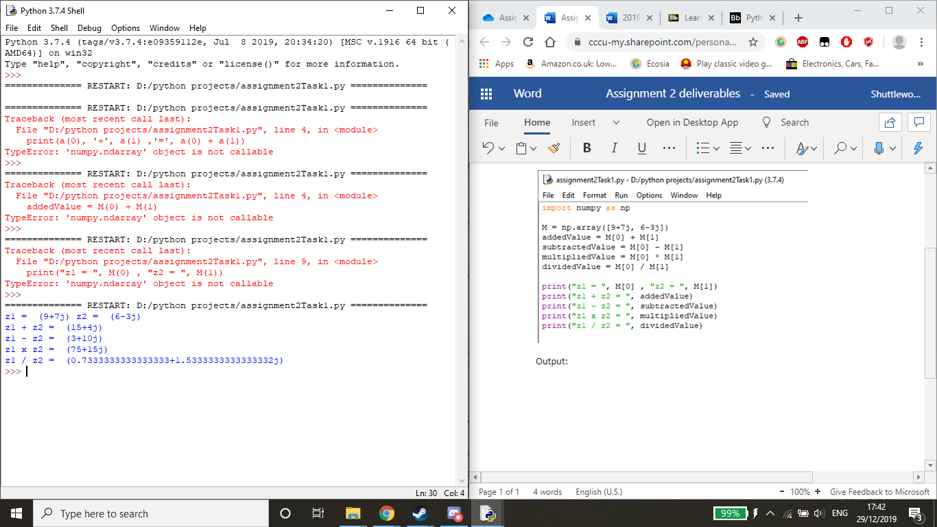

Task 2:

Working:

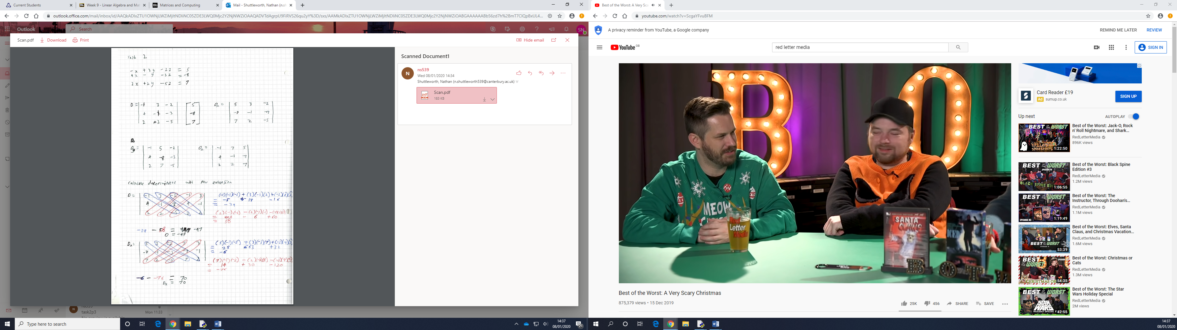

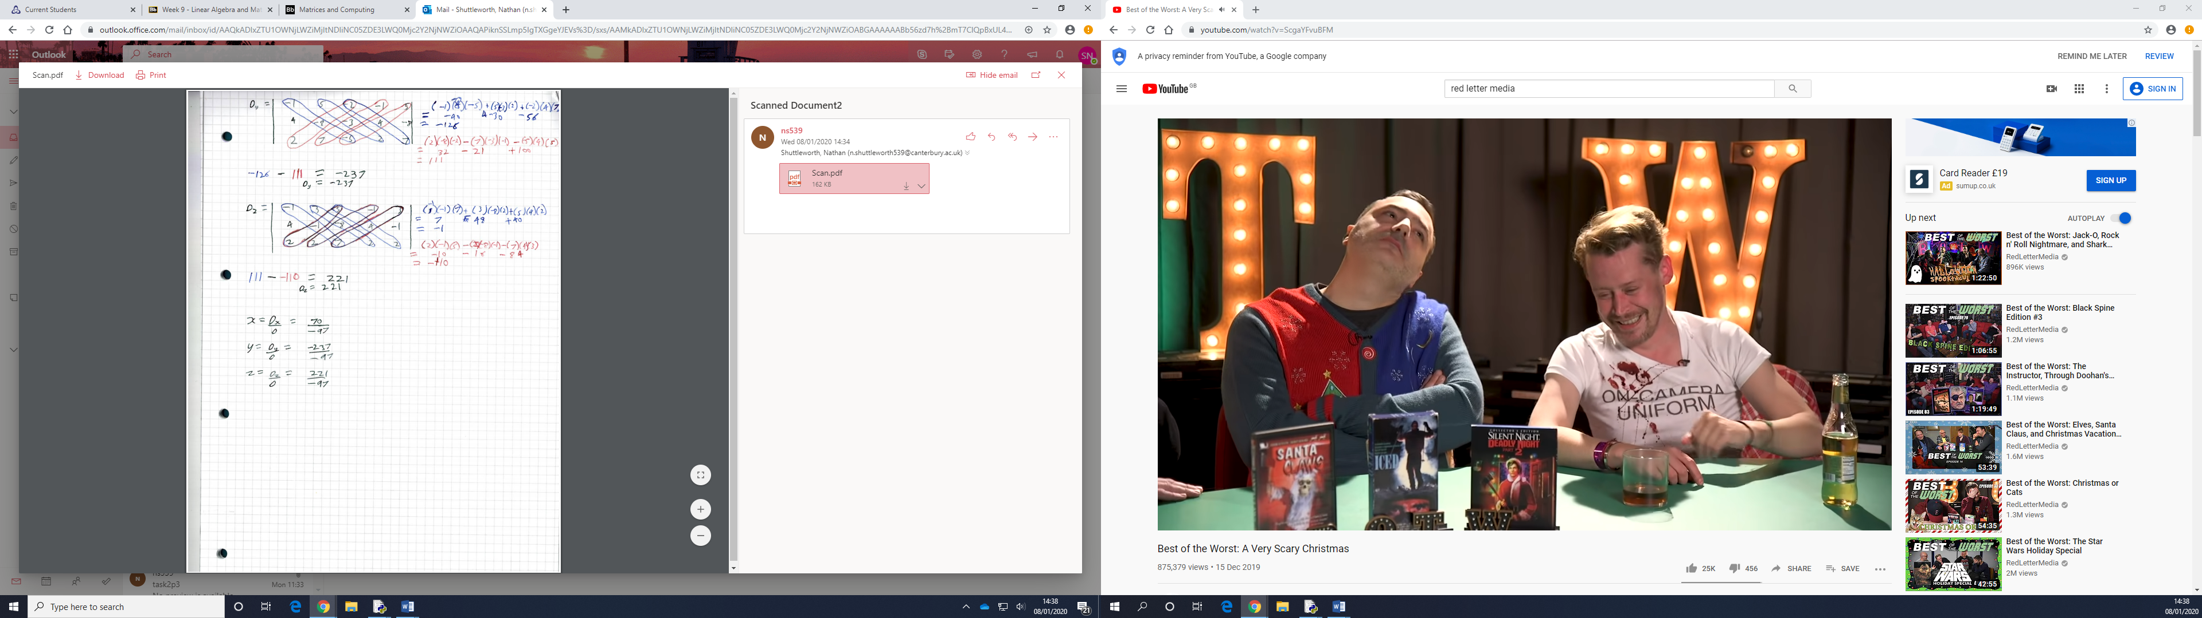

Python code:

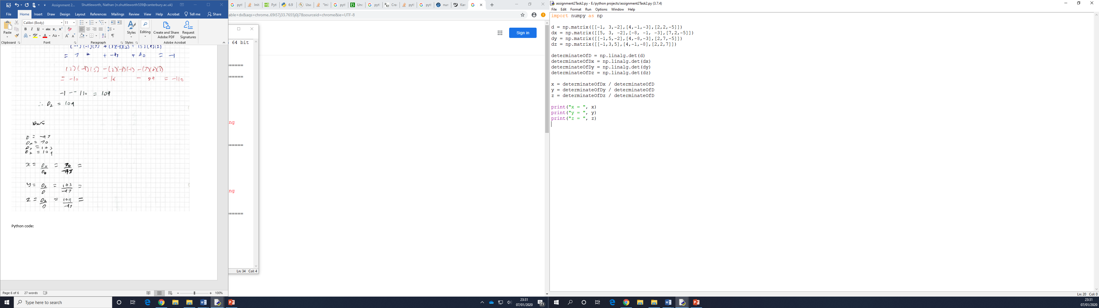

Output:

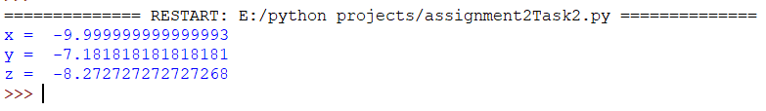

To complete this task I created 4 3x3 matrices using the coefficients from the linear equations. The first one just has the coefficients, the next 3 replace the first, second and third columns respectively with the answers to the linear equations. I then used the numpy function linalg.det() which allows you to find the determinate of a matrix. After this, I used the formulae from Cramer’s Rule to calculate the values of x, y and z respectively.

Task 3:

